NAME: VIGNESHWAR.D
REG.NO: 192524415
COURSE: CSA1515-Cloud Computing

EXPERIMENT 13
STUDENTS ATTENDANCE MANAGEMENT SYSTEM USING (SAAS)

AIM:
To create a simple cloud-based Students Attendance Management system Application Using Zoho Creator , a Saas Platform.

IMAGES:
Dashboard:
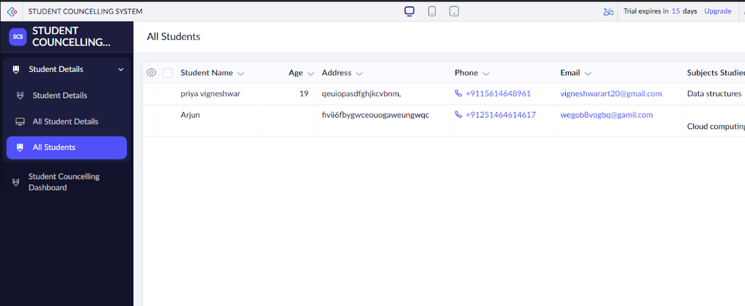

FORM:
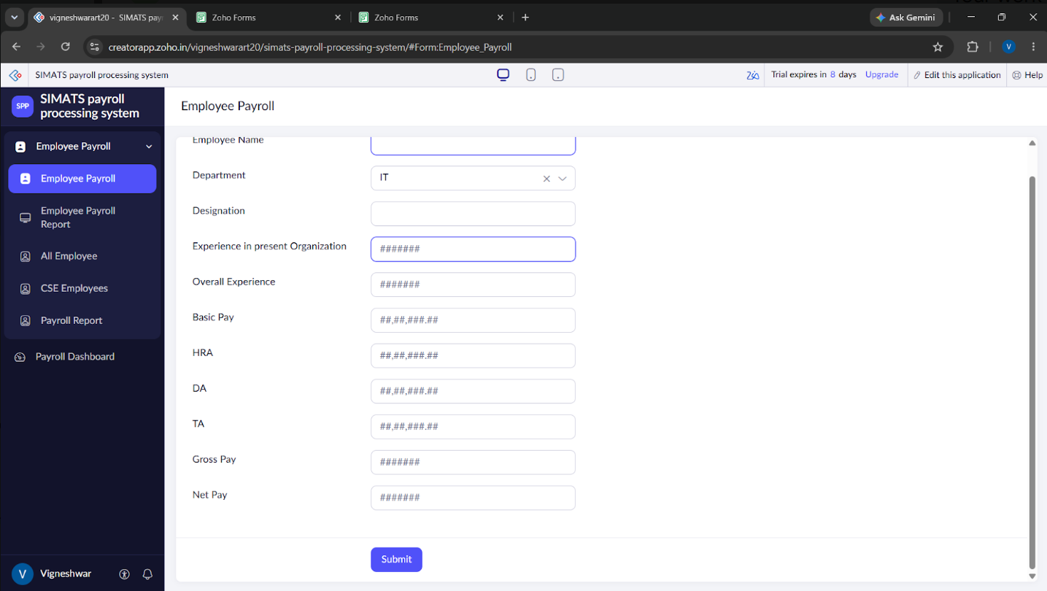

REPORT: 

